Linking myON and Star Results

Teachers will need to direct students to follow these steps to link their Star Reading and/or Star Early Literacy results to myON.
- Once students have logged into their myON account, they will see the banner as shown below. They will need to select Connect Now at the bottom of the banner.
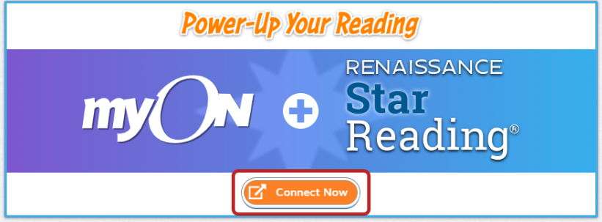

- Students will then automatically be taken to the school Renaissance Place site and be asked to enter their Renaissance Place username and password (i.e., the details they use to take Star tests and complete Accelerated Reader quizzes.)

- Once the details have been accepted, they will be directed back to myON. After a moment, they will see the Star Scaled Score (if the administrator has not disabled this option) from their most recent Star test and the ATOS ZPD that is based on that test.

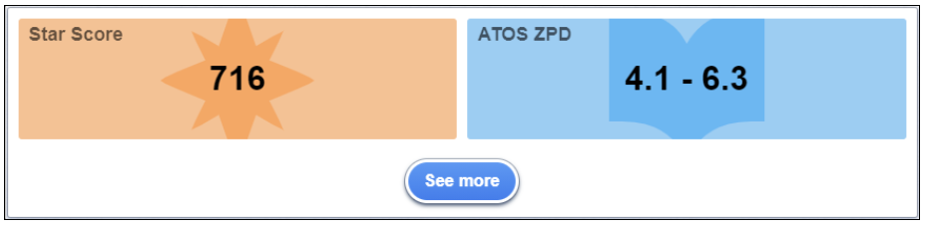

Their ZPD will now begin informing book recommendations and will make searching easier for students in myON!

