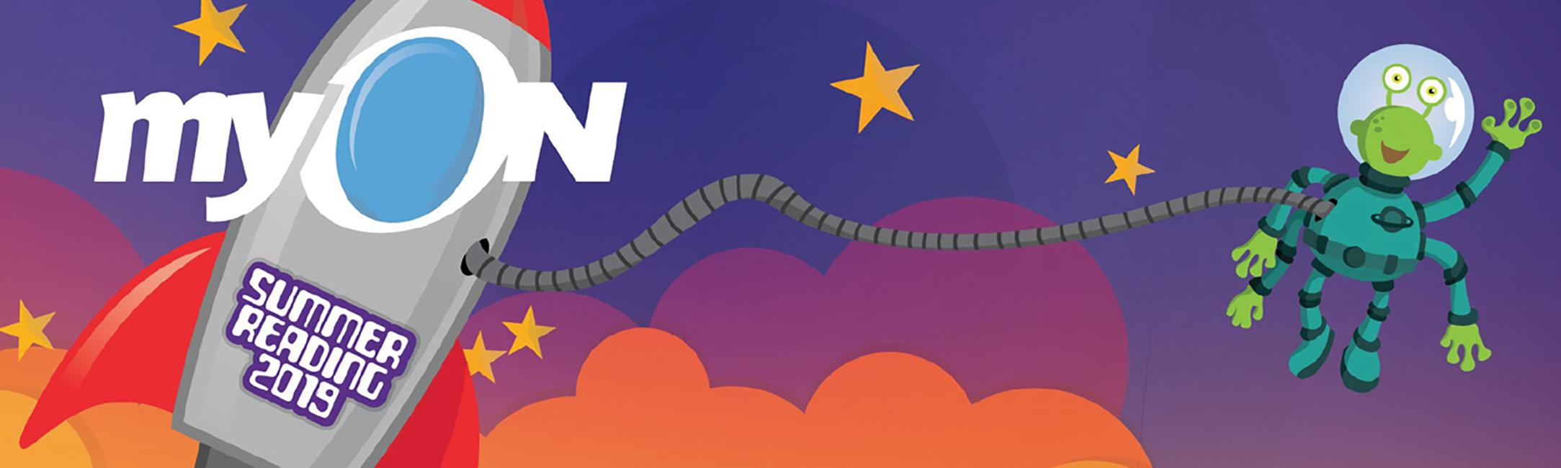

Dear Family,

Summer is a fun and exciting time for everyone to enjoy the outdoors, spend time with family and friends and simply relax. It is also a perfect opportunity to encourage children to read!

Over the summer, many students experience the summer slide, which can rob them of gains they made the previous school year. Children who do not read over the summer can lose more than two months of reading achievement. Unfortunately, summer reading loss is cumulative.

Together, we can help your child avoid the summer slide! Did you know that your child has FREE ACCESS to the myON Digital Library, a collection of more than 5,800 digital books to read over the summer on computers, laptops and other devices anytime, anywhere? myON contains books for every age, interest and reading level that will keep them engaged and learning all summer long!

To help encourage reading this summer, Renaissance has created a national reading program to motivate kids to read and will reward top schools with cool prizes. Please encourage your child to read as much as possible.

For more information, visit: www.renaissance.com.au/summer-reading-contest-nz

We hope your child will enjoy reading with us this summer!

The Renaissance myON Team

